

**PROJECT FOR MYSQL**

**Hollywood Theatrical Market Synopsis 1995 to 2021**



**NAME: Caesar Edwin**

**Email: edwincaesar029@gmail.com**

**Institute Name: IT Vedant**

**Project Aim**

To analyse and explore the trends, performance, and distribution patterns in the Hollywood theatrical market from 1995 to 2021 using a relational database, providing insights into ticket sales, box office performance, distributor strategies, genre preferences, creative types, and MPAA ratings.

**Project Objectives**

1. **Data Integration and Organization**
   * To design and implement a structured database using MySQL for managing Hollywood theatrical market data across multiple dimensions like ticket sales, movie genres, distributors, and MPAA ratings.
2. **Trend Analysis**
   * To analyse year-wise trends in ticket sales, box office revenue, and average ticket prices to evaluate the market’s growth and inflation-adjusted performance.
3. **Genre and Creative Type Insights**
   * To identify the most popular genres and creative types over the years by analysing their market share, total gross, and movie count.
4. **Distributor Performance**
   * To assess the performance of major distributors in terms of total gross, average gross, and market share.
5. **MPAA Ratings and Audience Patterns**
   * To study the impact of MPAA ratings on movie performance and identify which ratings dominate the market over time.
6. **Correlation Analysis**
   * To explore correlations between factors like ticket sales, average ticket prices, and inflation-adjusted box office gross.
7. **Query Optimization and Insights**
   * To demonstrate database querying techniques, including simple, subqueries, and joins, to extract meaningful insights from the dataset efficiently.
8. **Visualization and Reporting**
   * To present the findings through dashboards, charts, and reports, making it easier to interpret the market trends and patterns.

**ER DIAGRAM OF THE PROJECT**

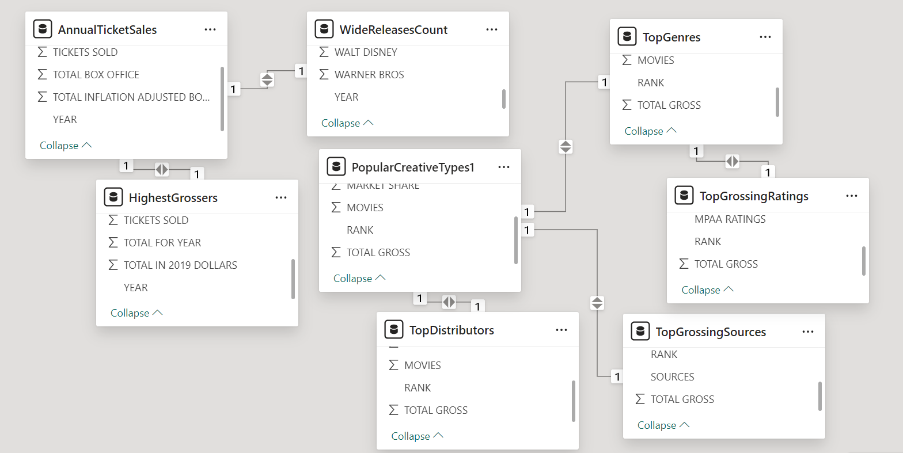

**TABLE DESCRIPTION 1. Annual Tickets Sales**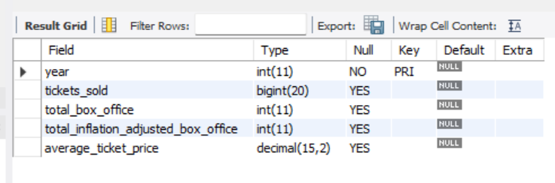

**TABLE DESCRIPTION 2. Highest Grosser**

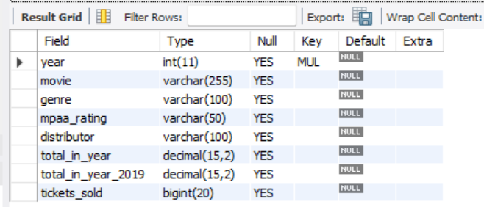

**TABLE DESCRIPTION 3. Popular Creative Types**

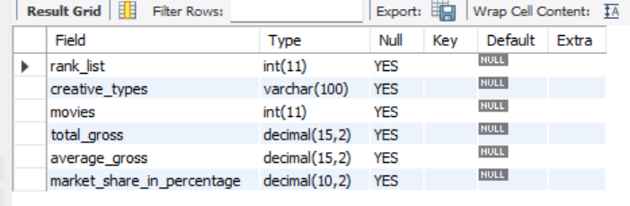

**TABLE DESCRIPTION 4. Top Distributor**

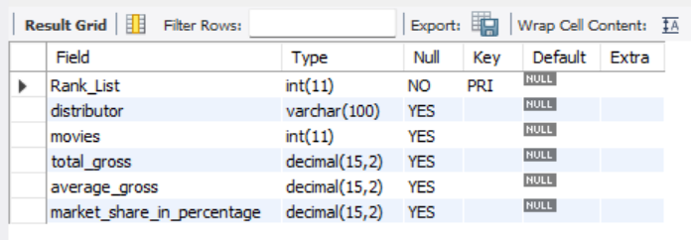

**TABLE DESCRIPTION 5. Top Genre**

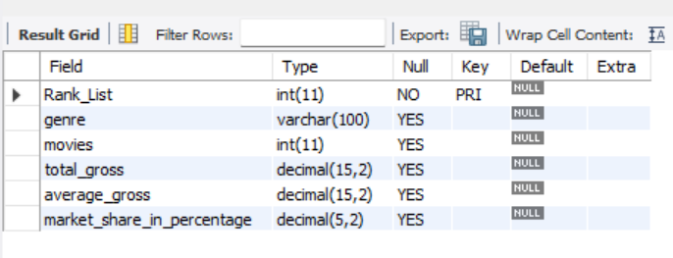

**TABLE DESCRIPTION 6. Top Grossing Rating**

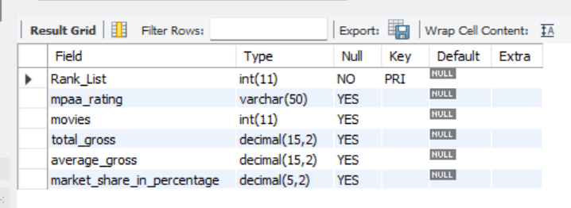

**TABLE DESCRIPTION 7. Top Grossing Source**

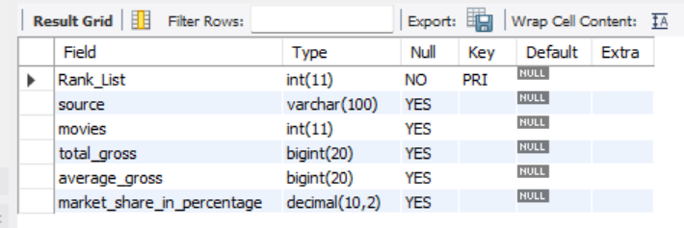

**TABLE DESCRIPTION 8. Wide Release Count**

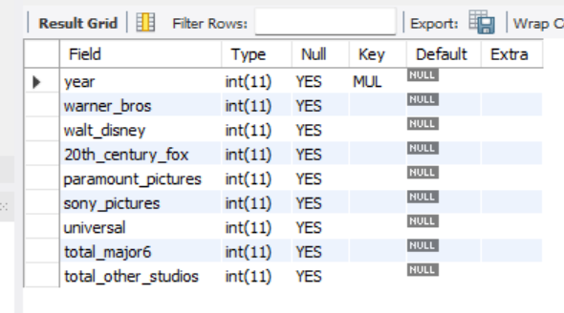

# COMMANDS

Create database Hollywood;

Use database Hollywood;

CREATE TABLE Annual_Ticket_Sales (

year INT PRIMARY KEY,

tickets_sold BIGINT,

total_box_office int,

total_inflation_adjusted_box_office int,

average_ticket_price decimal(15,2) );

INSERT INTO Annual_tickets_sales (YEAR, TICKETS SOLD, TOTAL BOX OFFICE, TOTAL INFLATION ADJUSTED BOX OFFICE, AVERAGE TICKET PRICE) VALUES

('2021', '423774881', '3881777912', '3881777912', '9.16'),

('2020', '223638958', '2048534616', '2048534616', '9.16'),

('2019', '1228541629', '11253443955', '11253444050', '9.16'),

('2018', '1311536128', '11948096650', '12013670952', '9.11'),

('2017', '1225639761', '10993991460', '11226860216', '8.97'),

('2016', '1302556378', '11267115924', '11931416424', '8.65'),

('2015', '1323356776', '11155900636', '12121948075', '8.43'),

('2014', '1257402920', '10272985008', '11517810744', '8.17'),

('2013', '1339168926', '10887446341', '12266787382', '8.13'),

('2012', '1380921942', '10992141616', '12649244986', '7.96'),

('2011', '1282915168', '10173519704', '11751502955', '7.93'),

('2010', '1328549021', '10482254025', '12169509032', '7.89'),

('2009', '1418567388', '10639257284', '12994051137', '7.5'),

('2008', '1358042073', '9750744148', '12439665380', '7.18'),

('2007', '1420036680', '9769854914', '13007535993', '6.88'),

('2006', '1398738283', '9161738221', '12812442671', '6.55'),

('2005', '1372980280', '8800805718', '12576499367', '6.41'),

('2004', '1495651298', '9287996519', '13700165883', '6.21'),

('2003', '1524589620', '9193277289', '13965240914', '6.03'),

('2002', '1575756527', '9155147215', '14433929789', '5.81'),

('2001', '1465874205', '8296849636', '13427407722', '5.66'),

('2000', '1397460079', '7532311479', '12800734319', '5.39'),

('1999', '1444664086', '7338894852', '13233123027', '5.08'),

('1998', '1443832471', '6771575283', '13225505439', '4.69'),

('1997', '1357349648', '6230235770', '12433322785', '4.59'),

('1996', '1305221290', '5769078886', '11955781912', '4.42'),

('1995', '1221705907', '5314421390', '11190826105', '4.35');

Select * from annual_ticket_sales

**output**

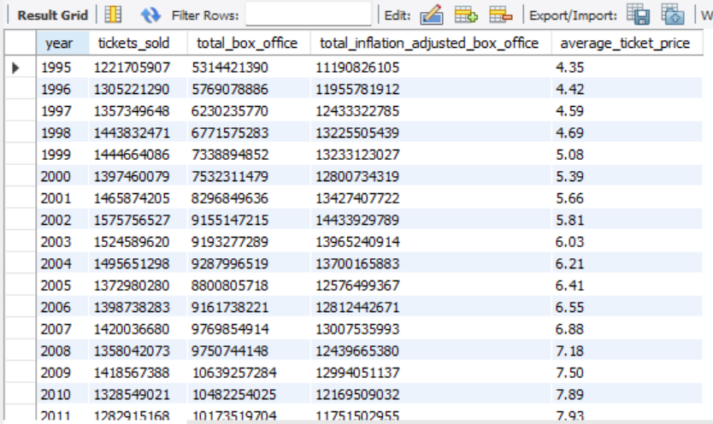

CREATE TABLE_Highest_Grosser (

year INT,

movie VARCHAR(255),

genre VARCHAR(100),

mpaa_rating VARCHAR(50),

distributor VARCHAR(100),

total_in_year DECIMAL(15, 2),

total_in_year_2019 DECIMAL(15, 2),

tickets_sold BIGINT,

FOREIGN KEY (year) REFERENCES Annual_Ticket_Sales(year)

);

INSERT INTO highest_grosser (YEAR, MOVIE, GENRE, MPAA RATING, DISTRIBUTOR, TOTAL FOR YEAR, TOTAL IN 2019 DOLLARS, TICKETS SOLD, null) VALUES

('1995', 'Batman Forever', 'Drama', 'PG-13', 'Warner Bros.', '184031112', '387522978', '42306002'),

('1996', 'Independence Day', 'Adventure', 'PG-13', '20th Century Fox', '306169255', '634504608', '69269062'),

('1997', 'Men in Black', 'Adventure', 'PG-13', 'Sony Pictures', '250650052', '500207943', '54607854'),

('1998', 'Titanic', 'Adventure', 'PG-13', 'Paramount Pictures', '443319081', '865842808', '94524324'),

('1999', 'Star Wars Ep. I: The Phantom Menace', 'Adventure', 'PG', '20th Century Fox', '430443350', '776153749', '84732942'),

('2000', 'How the Grinch Stole Christmas', 'Adventure', 'PG', 'Universal', '253367455', '430583644', '47006948'),

('2001', 'Harry Potter and the Sorcerer’s Stone', 'Adventure', 'PG', 'Warner Bros.', '300404434', '486166890', '53074988', ''),

('2002', 'Spider-Man', 'Adventure', 'PG-13', 'Sony Pictures', '403706375', '636480273', '69484746'),

('2003', 'Finding Nemo', 'Adventure', 'G', 'Walt Disney', '339714367', '516050346', '56337374'),

('2004', 'Shrek 2', 'Adventure', 'PG', 'DreamWorks SKG', '441226247', '650826473', '71050925'),

('2005', 'Star Wars Ep. III: Revenge of the Sith', 'Action', 'PG-13', '20th Century Fox', '380270577', '543413171', '59324582'),

('2006', 'Pirates of the Caribbean: Dead Mans Chest', 'Action', 'PG-13', 'Walt Disney', '423315812', '591995851', '64628368'),

('2007', 'Spider-Man 3', 'Adventure', 'PG-13', 'Sony Pictures', '336530303', '448054878', '48914288'),

('2008', 'The Dark Knight', 'Adventure', 'PG-13', 'Warner Bros.', '531001578', '677433772', '73955652'),

('2009', 'Transformers: Revenge of the Fallen', 'Action', 'PG-13', 'Paramount Pictures', '402111870', '491112631', '53614916'),

('2010', 'Toy Story 3', 'Action', 'G', 'Walt Disney', '415004880', '481805411', '52598844'),

('2011', 'Harry Potter and the Deathly Hallows: Part II', 'Action', 'PG-13', 'Warner Bros.', '381011219', '440108798', '48046812'),

('2012', 'The Avengers', 'Adventure', 'PG-13', 'Walt Disney', '623357910', '717331462', '78311295'),

('2013', 'Iron Man 3', 'Adventure', 'PG-13', 'Walt Disney', '408992272', '460808016', '50306552'),

('2014', 'Guardians of the Galaxy', 'Adventure', 'PG-13', 'Walt Disney', '333055258', '373413235', '40765637'),

('2015', 'Star Wars Ep. VII: The Force Awakens', 'Action', 'PG-13', 'Walt Disney', '742208942', '806480887', '88043765'),

('2016', 'Finding Dory', 'Action', 'PG', 'Walt Disney', '486295561', '514967322', '56219140'),

('2017', 'Star Wars Ep. VIII: The Last Jedi', 'Action', 'PG-13', 'Walt Disney', '517218368', '528173936', '57660910'),

('2018', 'Black Panther', 'Action', 'PG-13', 'Walt Disney', '700059566', '703901821', '76845177'),

('2019', 'Avengers: Endgame', '', 'PG-13', 'Walt Disney', '858373000', '858373002', '93708843'),

('2020', 'Bad Boys For Life', '', 'R', 'Sony Pictures', '204417855', '204417848', '22316359'),

('2021', 'Shang-Chi and the Legend of the Ten Rings', '', 'PG-13', 'Walt Disney', '224226704', '224226704', '24478897');

Select * from Highest_grosser

**Output**

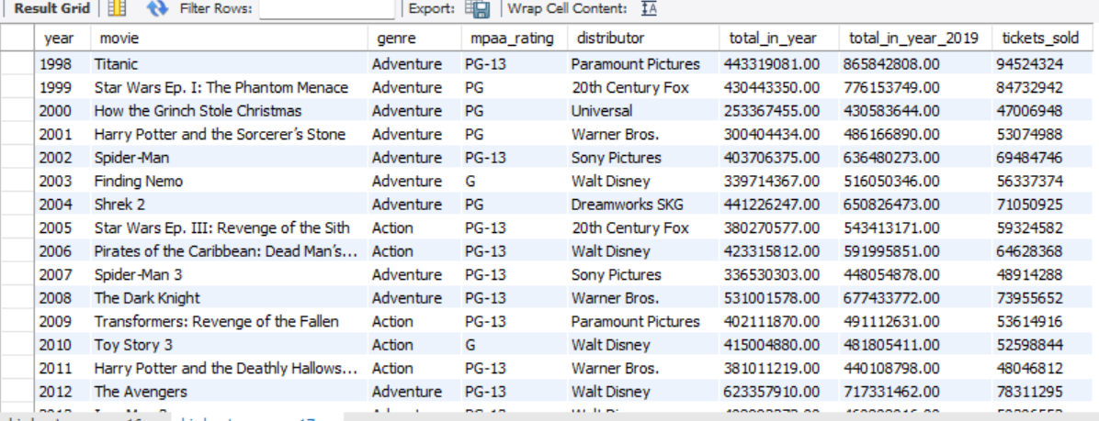

CREATE TABLE Popular_Creative_Types (

rank_list INT,

creative_types VARCHAR(100),

movies INT,

total_gross DECIMAL(15, 2),

average_gross DECIMAL(15, 2),

market_share_in_percentage decimal(10,2)

);

INSERT INTO Popular_creatice_types (RANK, CREATIVE TYPES, MOVIES, TOTAL GROSS, AVERAGE GROSS, MARKET SHARE) VALUES

('1', 'Contemporary Fiction', '7442', '96203727036', '12927133', '40.46%'),

('2', 'Kids Fiction', '564', '32035539746', '56800602', '13.47%'),

('3', 'Science Fiction', '724', '29922660857', '41329642', '12.59%'),

('4', 'Fantasy', '759', '21724062575', '28621953', '9.14%'),

('5', 'Super Hero', '129', '20273157911', '157156263', '8.53%'),

('6', 'Historical Fiction', '1487', '18521260744', '12455454', '7.79%',),

('7', 'Dramatization', '1175', '15715191699', '13374631', '6.61%'),

('8', 'Factual', '2467', '2960327207', '1199970', '1.25%'),

('9', 'Multiple Creative Types', '42', '117574526', '2799393', '0.05%');

Select * from Popular_creative_types

**Output**

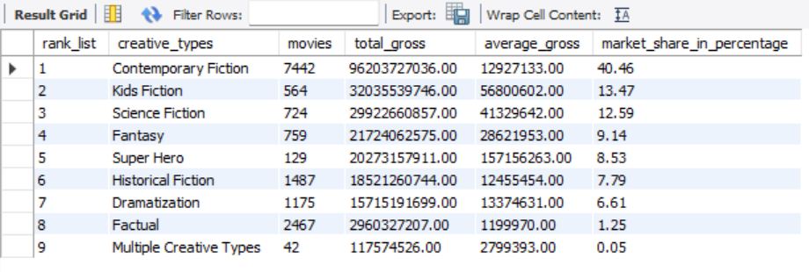

CREATE TABLE Top_Distributor (

Rank_List INT PRIMARY KEY,

distributor VARCHAR(100),

movies INT,

total_gross DECIMAL(15, 2),

average_gross DECIMAL(15, 2),

market_share_in_percentage decimal(15,2)

);

INSERT INTO Top_Distributor (RANK, DISTRIBUTORS, MOVIES, TOTAL GROSS, AVERAGE GROSS, MARKET SHARE) VALUES

('1', 'Walt Disney', '588', '40472424278', '68830654', '17.02%'),

('2', 'Warner Bros.', '824', '36269425479', '44016293', '15.25%'),

('3', 'Sony Pictures', '747', '29113002302', '38973229', '12.24%'),

('4', 'Universal', '535', '28089932569', '52504547', '11.81%'),

('5', '20th Century Fox', '525', '25857839756', '49253028', '10.88%'),

('6', 'Paramount Pictures', '493', '24361425304', '49414656', '10.25%'),

('7', 'Lionsgate', '426', '9631837781', '22609948', '4.05%'),

('8', 'New Line', '209', '6195268024', '29642431', '2.61%'),

('9', 'Dreamworks SKG', '77', '4278649271', '55566874', '1.80%'),

('10', 'Miramax', '385', '3836019208', '9963686', '1.61%');

Select * from Top_Distributor

**Output**

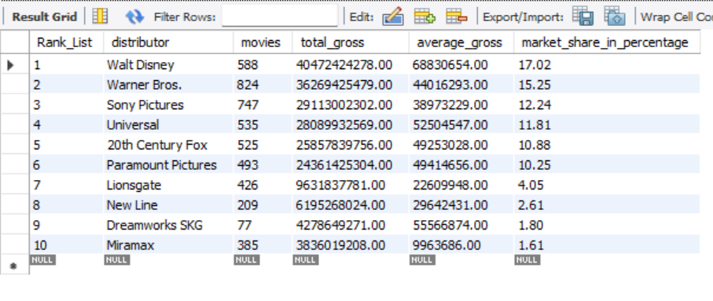

CREATE TABLE Top_Genre (

Rank_List INT PRIMARY KEY,

genre VARCHAR(100),

movies INT,

total_gross DECIMAL(15, 2),

average_gross DECIMAL(15, 2),

market_share_in_percentage DECIMAL(5, 2)

);

INSERT INTO Top_Genre (RANK, GENRES, MOVIES, TOTAL GROSS, AVERAGE GROSS, MARKET SHARE, ) VALUES

('1', 'Adventure', '1102', '64529536530', '58556748', '27.14'),

('2', 'Action', '1098', '49339974493', '44936224', '20.75'),

('3', 'Drama', '5479', '35586177269', '6495013', '14.97'),

('4', 'Comedy', '2418', '33687992318', '13932172', '14.17'),

('5', 'Thriller/Suspense', '1186', '19810201102', '16703374', '8.33'),

('6', 'Horror', '716', '13430378699', '18757512', '5.65'),

('7', 'Romantic Comedy', '630', '10480124374', '16635118', '4.41'),

('8', 'Musical', '201', '4293988317', '21363126', '1.81'),

('9', 'Documentary', '2415', '2519513142', '1043277', '1.06'),

('10', 'Black Comedy', '213', '2185433323', '10260250', '0.92');

Select * from Top_Genre

**Output**

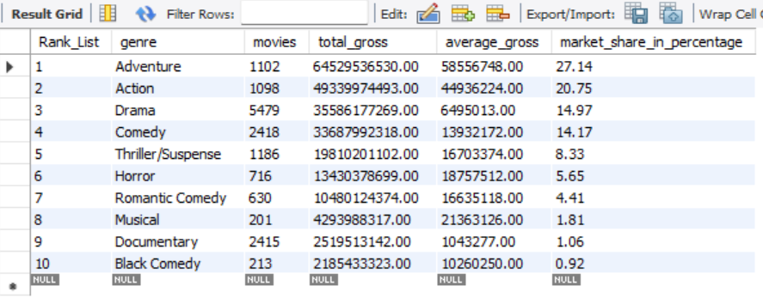

CREATE TABLE Top_Grossing_Rating (

Rank_List INT PRIMARY KEY,

mpaa_rating VARCHAR(50),

movies INT,

total_gross DECIMAL(15, 2),

average_gross DECIMAL(15, 2),

market_share_in_percentage DECIMAL(5, 2)

);

INSERT INTO Top_Grossing_rating (RANK, MPAA RATINGS, MOVIES, TOTAL GROSS, AVERAGE GROSS, MARKET SHARE, ) VALUES

('1', 'PG-13', '3243', '113524789243', '35006102', '47.75%'),

('2', 'R', '5480', '63497164978', '11587074', '26.71%'),

('3', 'PG', '1535', '49124317794', '32002813', '20.66%'),

('4', 'G', '395', '9572240391', '24233520', '4.03%'),

('5', 'Not Rated', '5820', '1918358283', '329615', '0.81%'),

('6', 'NC-17', '24', '44850139', '1868756', '0.02%'),

('7', 'Open', '5', '5489687', '1097937', '0.00%'),

('8', 'GP', '7', '552618', '78945', '0.00%');

Select * from Top_Grossing_Rating

**Output**

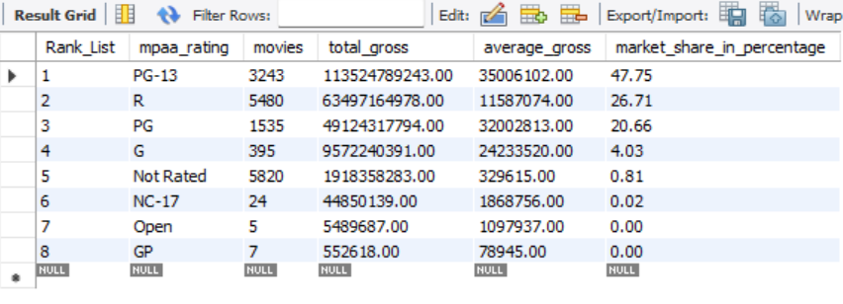

CREATE TABLE Top_Grossing_Source (

Rank_List INT PRIMARY KEY,

source VARCHAR(100),

movies INT,

total_gross int,

average_gross int,

market_share_in_percentage decimal(10,2));

INSERT INTO Top_Grossing_source (RANK, SOURCES, MOVIES, TOTAL GROSS, AVERAGE GROSS, MARKET SHARE) VALUES

('1', 'Original Screenplay', '7946', '106375196782', '13387264', '44.74%'),

('2', 'Based on Fiction Book/Short Story', '2150', '47005613207', '21863076', '19.77%'),

('3', 'Based on Comic/Graphic Novel', '249', '23369989130', '93855378', '9.83%'),

('4', 'Remake', '328', '12832659970', '39123963', '5.40%'),

('5', 'Based on Real Life Events', '3225', '11398356297', '3534374', '4.79%'),

('6', 'Based on TV', '231', '11305006312', '48939421', '4.75%'),

('7', 'Based on Factual Book/Article', '295', '7443681990', '25232820', '3.13%'),

('8', 'Spin-Off', '41', '3833128331', '93490935', '1.61%'),

('9', 'Based on Folk Tale/Legend/Fairytale', '78', '3406118495', '43668186', '1.43%'),

('10', 'Based on Play', '271', '2111190923', '7790372', '0.89%');

Select * from Top_Grossing_Source

**Output**

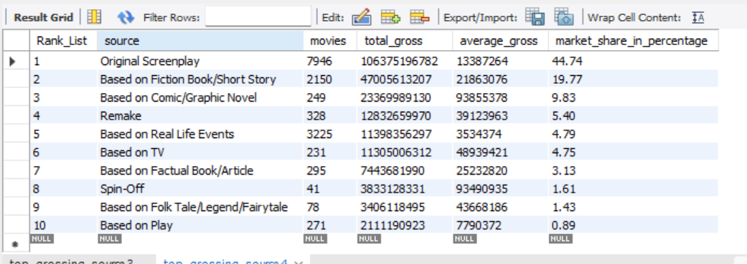

create TABLE Wide_Release_Count (

year INT,

warner_bros INT,

walt_disney INT,

20th_century_fox INT,

paramount_pictures INT,

sony_pictures INT,

universal INT,

total_major6 INT,

total_other_studios INT,

FOREIGN KEY (year) REFERENCES Annual_Ticket_Sales(year)

);

INSERT INTO wide_release_count (YEAR, WARNER BROS, WALT DISNEY, 20TH CENTURY FOX, PARAMOUNT PICTURES, SONY PICTURES, UNIVERSAL, TOTAL MAJOR 6, TOTAL OTHER STUDIOS) VALUES

('2021', '17', '7', '0', '4', '16', '17', '61', '38'),

('2020', '5', '3', '1', '3', '9', '13', '34', '23'),

('2019', '18', '10', '11', '9', '18', '21', '87', '44'),

('2018', '19', '10', '11', '10', '16', '20', '86', '58'),

('2017', '18', '8', '14', '10', '16', '15', '81', '50'),

('2016', '17', '12', '16', '12', '16', '22', '95', '46'),

('2015', '22', '11', '18', '9', '13', '20', '93', '33'),

('2014', '17', '12', '17', '10', '17', '15', '88', '37'),

('2013', '17', '8', '15', '8', '14', '16', '78', '42'),

('2012', '16', '11', '15', '13', '18', '17', '90', '42'),

('2011', '20', '13', '15', '13', '21', '19', '101', '35'),

('2010', '20', '12', '18', '12', '17', '17', '96', '30'),

('2009', '25', '14', '20', '10', '21', '21', '111', '30'),

('2008', '19', '11', '22', '14', '19', '19', '104', '48'),

('2007', '30', '13', '17', '16', '22', '20', '118', '50'),

('2006', '26', '17', '25', '13', '26', '21', '128', '31'),

('2005', '20', '20', '19', '12', '19', '17', '107', '30'),

('2004', '27', '25', '18', '14', '15', '14', '113', '25'),

('2003', '28', '19', '13', '14', '19', '13', '106', '23'),

('2002', '32', '23', '15', '16', '20', '13', '119', '21'),

('2001', '30', '16', '16', '14', '17', '10', '103', '25'),

('2000', '29', '22', '13', '12', '15', '13', '104', '27'),

('1999', '27', '20', '15', '13', '22', '16', '113', '19'),

('1998', '27', '21', '11', '11', '20', '16', '106', '20'),

('1997', '31', '22', '12', '16', '22', '11', '114', '22'),

('1996', '31', '23', '13', '16', '24', '13', '120', '22'),

('1995', '27', '22', '11', '12', '20', '17', '109', '27');

Select * from Wide_Release_Count

**Output**

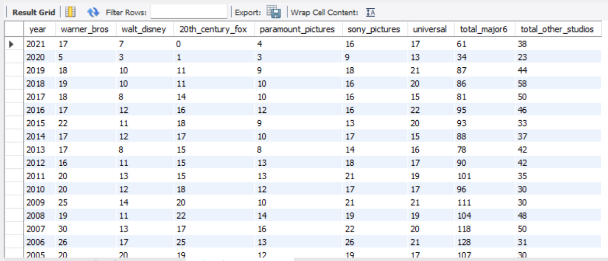

**Basic QUERIES**

**1. To Find Total box office earning for each year 2003**

**QUERY:** select year, total_Box_Office from annual_ticket_sales where year= "2003";

**OUTPUT**

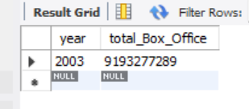

**2. To list all movies where MPAA Rating IS PG-13**

**QUERY**:SELECT YEAR ,MOVIE

FROM highest_grosser

WHERE MPAA_RATING = "PG-13";

**OUTPUT**

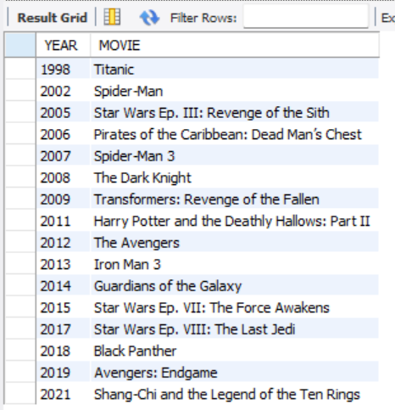

**3. TO DISPLAY THE TOP 5 GENRE WITH THE HIGHST AVERAGE GROSSING**

**QUERY**: SELECT GENRE, AVERAGE_GROSS FROM TOP_GENRE ORDER BY AVERAGE_GROSS desc LIMIT 5;

**OUTPUT**

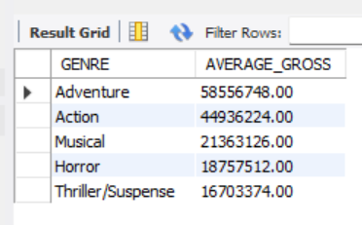

**4. TO Find top 3 distributors as per the market share**

**QUERY:** select Distributor, Market_share_in_percentage from Top_Distributor

order by Market_share_in_percentage desc limit 3;

**OUTPUT**

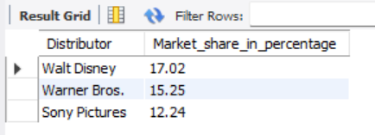

**5. TO FIND CREATIVE TYPES WITH TOTAL GROSS GREATER THAN 1 BILLION**

**QUERY**: SELECT CREATIVE_TYPES, TOTAL_GROSS FROM

popular_creative_types where total_gross > 1000000000;

**OUTPUT**

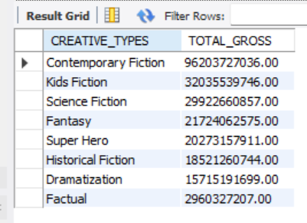

**SUB-QUERIES**

**1.To find the movies with highest tickets sold in any year**

**QUERY**: select year, movie,tickets_sold

from highest_grosser

where tickets_sold = ( select max(tickets_sold) from

highest_grosser);

**OUTPUT**

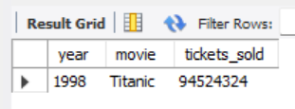

**2. To find genre with highest total gross**

**QUERY**: select genre, total_gross

from Top_Genre

where total_gross = (select max(total_gross) from top_genre);

**Output**

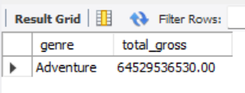

**3.** **To find the MPAA Rating with highest market share**

**QUERY**: select MPAA_Rating,market_share_in_percentage

from top_grossing_rating

where market_share_in_percentage = (select max(market_share_in_percentage) from top_grossing_rating);

**Output**

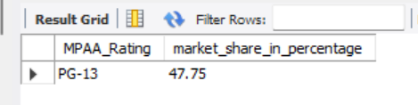

**4.To List all source with an average gross higher than the overall average gross of all source**

QUERY: select source, average_gross

from top_grossing_source

where average_gross > (select avg(average_gross) from top_grossing_source);

**Output**

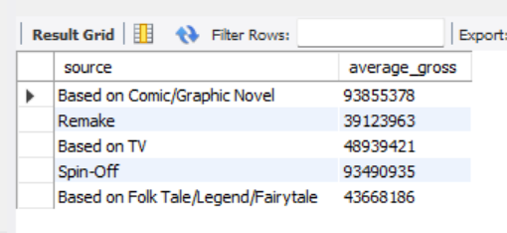

**5. to find the year where warner bros released highest number of movies**

**QUERY**: select year from wide_release_count

where warner_bros = (select max(warner_bros) from wide_release_count);

**Output**

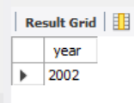

**QUERIES WITH JOIN**

**1.** **to display each genres market share in percentage and corresponding MPAA Ratings**

**QUERY**: select tg.genre, tg.market_share_in_percentage as genre_market_share_in_percentage, tgr.mpaa_rating,

tgr.market_share_in_percentage as rating_market_share_in_percentage

from top_genre as tg

join top_grossing_rating as tgr on

tg.Rank_List = tgr.Rank_List;

**Output**

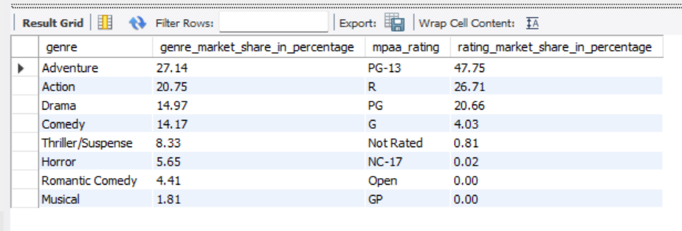

**2. top movie each year with its average ticket price**

**QUERY**: select h.year, h.movie, h.total_in_year, a.average_ticket_price

from highest_grosser as h

join annual_tickets_sales as a on

h.year = a.year;

**Output**

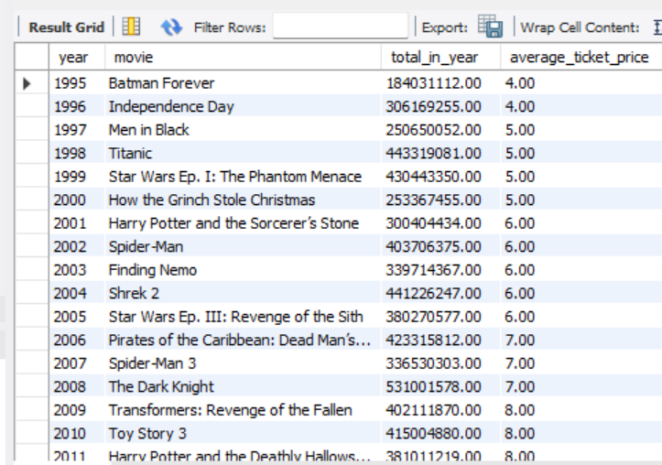

**3.to find total gross for each source with the top distributor**

**QUERY**: select tgs.source, tgs.total_gross as source_total_gross, td.distributor,td.total_gross as distributor_total_gross

from top_grossing_source as tgs

join top_distributor as td

on tgs.Rank_List = td.Rank_List;

**Output**

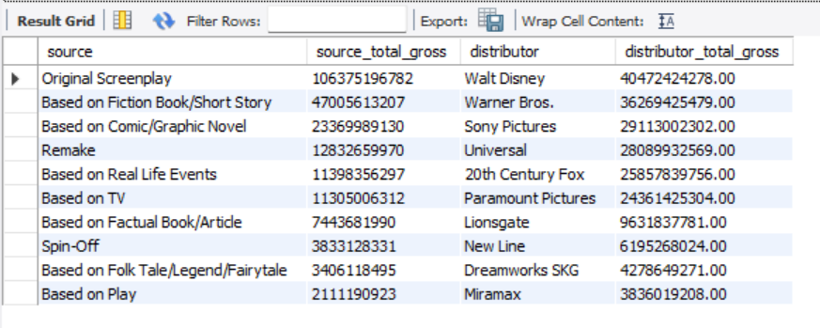

**4.** **to display genre and creative type by total gross**

**QUERY**: select tg.Rank_List, tg.genre, tg.total_gross as genres_total_gross,

pct.creative_types, pct.total_gross as creative_total_gross

from top_genre as tg

join popular_creative_types as pct

on tg.rank_list = pct.rank_list;

**Output**

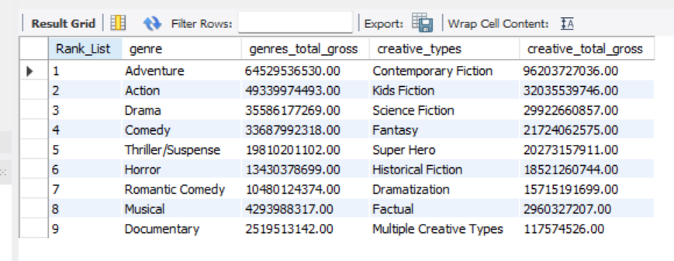

**5. MPAA Rating and creative types by total gross**

**QUERY**: select tgr.rank_list, tgr.mpaa_rating, tgr.total_gross as rating_total_gross ,

pct.creative_types, pct.total_gross as creative_total_gross

from top_grossing_rating as tgr

join popular_creative_types as pct

on tgr.Rank_List = pct.Rank_List;

**Output**

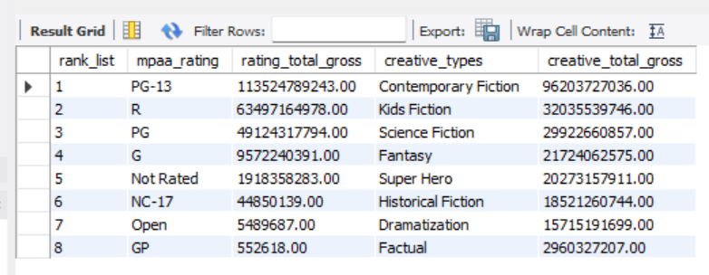

**Conclusion:**

The Hollywood Theatrical Market Synopsis (1995 to 2021) highlights the evolution of the film industry, showcasing steady box office growth driven by rising ticket prices, though ticket sales have not kept pace, indicating potential stagnation in audience turnout. Major studios like Disney, Warner Bros, and Universal dominate the market, leveraging wide release strategies and established franchises to secure significant revenue. Family-friendly, PG-13-rated films and genres like action, animation, and superhero movies consistently outperform others, reflecting changing audience preferences. The rise of adaptations and technological advancements, such as CGI, underscores Hollywood’s reliance on proven formulas to maximize profits. Inflation-adjusted figures reveal a nuanced perspective on growth, emphasizing the real impact of pricing and economic factors over time.